**DAILY ONLINE ACTIVITIES SUMMARY**

|  |  |  |  |  |  |  |  |  |
| --- | --- | --- | --- | --- | --- | --- | --- | --- |
| **Date:** | **25/05/2020** | | | | | **Name:** | **Manish B Shriyan** | |
| **Sem & Sec** | **8th sem B sec** | | | | | **USN:** | **4AL16CS131** | |
| **Online Test Summary** | | | | | | | | |
| **Subject** | | **---** | | | | | | |
| **Max. Marks** | | **--** | | **Score** | | | **--** | |
| **Certification Course Summary** | | | | | | | | |
| **Course** | **Introduction to Amazon Virtual Private Cloud(VPC)** | | | | | | | |
| **Certificate Provider** | | | **AWS** | | **Duration** | | | **2 Hours** |
| **Coding Challenges** | | | | | | | | |
| **Problem Statement:**  **Python program to find sum of elements in list** | | | | | | | | |
| **Status: Solved** | | | | | | | | |
| **Uploaded the report in Github** | | | | | **Uploaded** | | | |
| **If yes Repository name** | | | | | **ManishShriyan** | | | |
| **Uploaded the report in slack** | | | | | **Yes** | | | |

Online Test Details:

No test conducted

Certification Course Details:

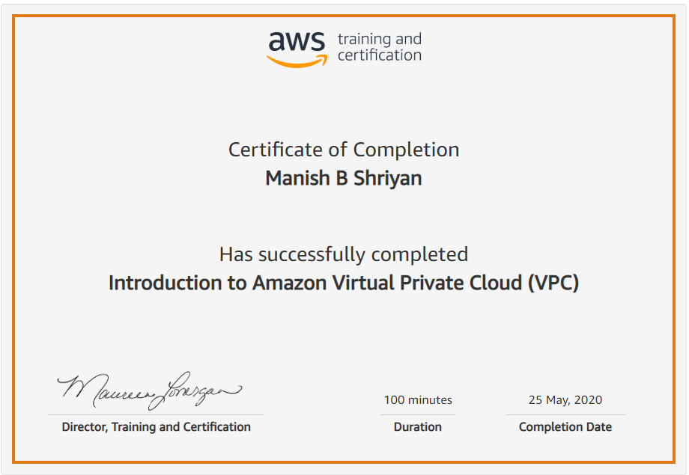

Coding Challenges Details:

# Python program to find sum of elements in list

total = 0

# creating a list

list1 = [11, 5, 17, 18, 23]

# Iterate each element in list

# and add them in variale total

for ele in range(0, len(list1)):

    total = total + list1[ele]

# printing total value

print("Sum of all elements in given list: ", total)